BEACH MEETING MINUTES - November 19, 2019

Attended: Beverly Nemiroff, Lil Sweet, Pat Degnan, Ami Nickel, Charlie Bogusat, Mike Ilardi
Time: 7:00 - 7:35PM

- New Business: No Smoking something new on our three beaches and two pools will be in effect for the 2020 season. Signs will be posted at each location. Agreed by committee
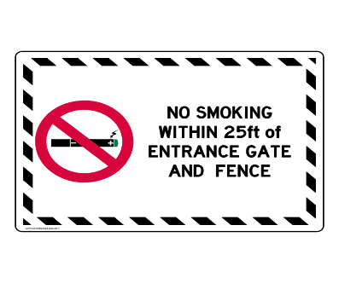
- Beaches: Sand will be scheduled for delivery on Beach 1, Beach 2, & Beach 3 the first week of June.
- Concession stand advertising will be posted in the newsletter in the new year for interested vendors to run the Beach 1 stand for the summer season.
- The beach meeting time has changed it will be held on the 2nd Wednesday of the month at 7:40PM

Next Monthly Meeting Wed., December 11, 2019 @ 7:40PM
Prepared by Beverly Nemiroff
Co-chairs Beverly Nemiroff & Ami Nickel
Approved by Mike Ilardi

