LAKE COMMITTEE MINUTES
March 7, 2019 START 7:30 pm FINISH__8:45 pm_________
Old Business
- Unanimous approval of the minutes from February meeting.
- Board approved the motion for Solitude Lake Management as applicators for 2019 season. Committee chair negotiated a savings of nearly $5,000 for 2019.
- Board approved three motions for fish stocking: minnows, perch and trout. The Solitude article on fish stocking was shared and discussed. It was noted that our stocking plan is largely aligned with the expert’s opinion. Stocking of fat head minnows is helping keep our primary fish population (Bass, Blue Gill, etc,) healthy. Perch is a new addition this year that will help the lake ecosystem and is a good pan fish for residents.
- It was emphasized that carp are harmful to the lake ecosystem as they eat the eggs of the desirable fish such as bass, blue gill and perch, reducing their population. It is a N.J. State regulation to not return carp, if caught.
  - Observations indicate the carp population is growing, which if not controlled, will become problematic. The idea of a carp “round-up” or “rodeo” was discussed. Don’t call it a “Contest”, makes it seem like a prize fish, which it is not. The May timeframe would be good for this. Details need to be worked out including duration the program, how fish caught are recorded and disposed of, and awards.
  - The committee agreed we should be clear about the intent to remove the carp, explaining they are an invasive species to the lake. Next step is to learn more from other lakes as to what they do and finalize a proposal for this.
- Lake Rescue equipment (throw bag) update : There is now one throw bag each in the boat house, security and maintenance vehicle. The Committee believes throw bags, rings and rescue hooks could be placed at locations around the lake, in cabinets and/or bolted to the side of existing structures such as life guard stands, dock section or fence post. Take measures to prevent theft or inappropriate use. More consideration is needed. This should not come exclusively from the lake committee as it is a cross committee and Board level topic.
New Business
- Review of Boating Safety / Docking Guide – awaiting from John O and Ed
- Severe Weather/Hurricane Plan is in development to be shared with the Committee. Will consult with other lakes at the COLA meeting.
- Boat Registration Days – Committee member volunteers needed on each of the 3 days to help with the process. Be at clubhouse before 8:00 am to help ensure people have their information and to answer questions.
- a member demonstrated a pair of self-rescue ice awls he always wears when on the ice and that wearing a lanyard whistle can help attract help. Sports or fishing groups using the ice could keep a throw bag with them.
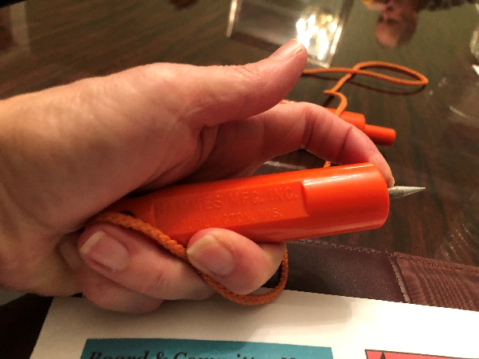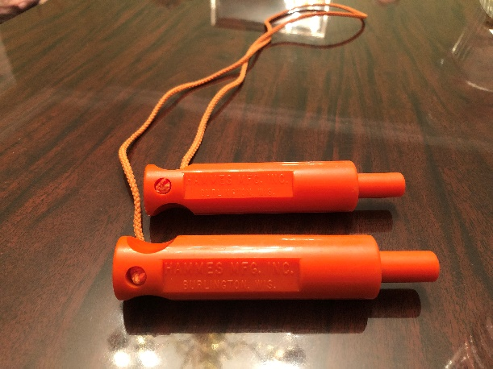
- Temporary boat space was discussed. What if any guidance is needed from us.
- Goose Management Plan - Our committee has not decided what it is we should do if anything.
- Reminder: COLA meeting April 13th at Lake Mohawk Clubhouse
- Other topics as time permits – Next Meeting topic request: Lake perimeter plantings (Mike F.)

Attendees: Michael Freedman, Tom Alameda, Alan Zenkert, Russ Pencak, Keith Small, James Devonmille, Mark Didriksen, Gerry Primavera, Bob Fehon, Joanne Machalaba

Prepared by Joanne Machalaba & Bob Fehon
Approved by Mark Kempner-OIC

